DBSE Week 3
Created collection called book1 in BookFlow database
In book1 we already inserted 3 books with their names review and ratings .
Reviews are stored directly inside the book document.
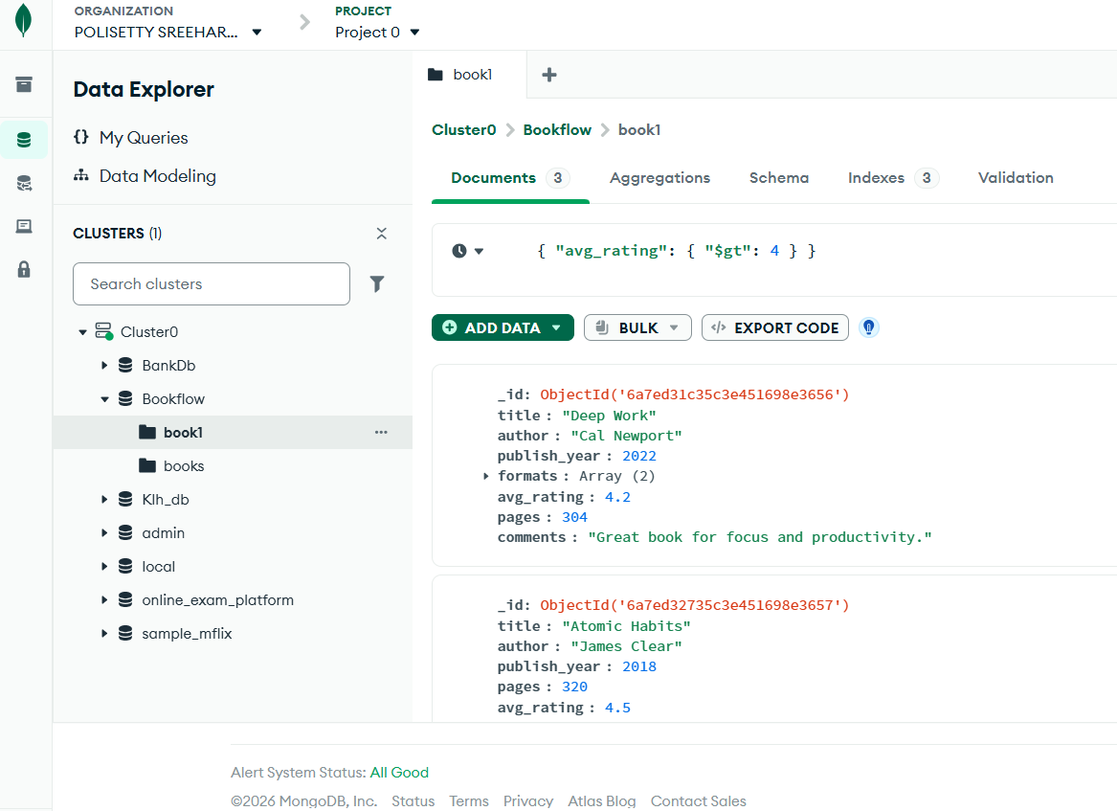

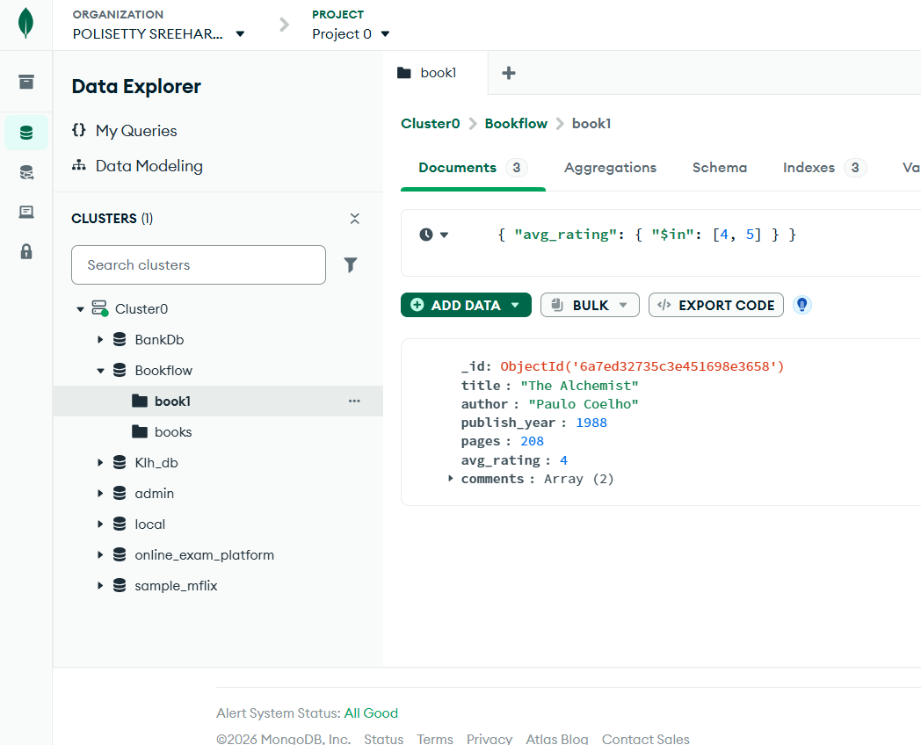

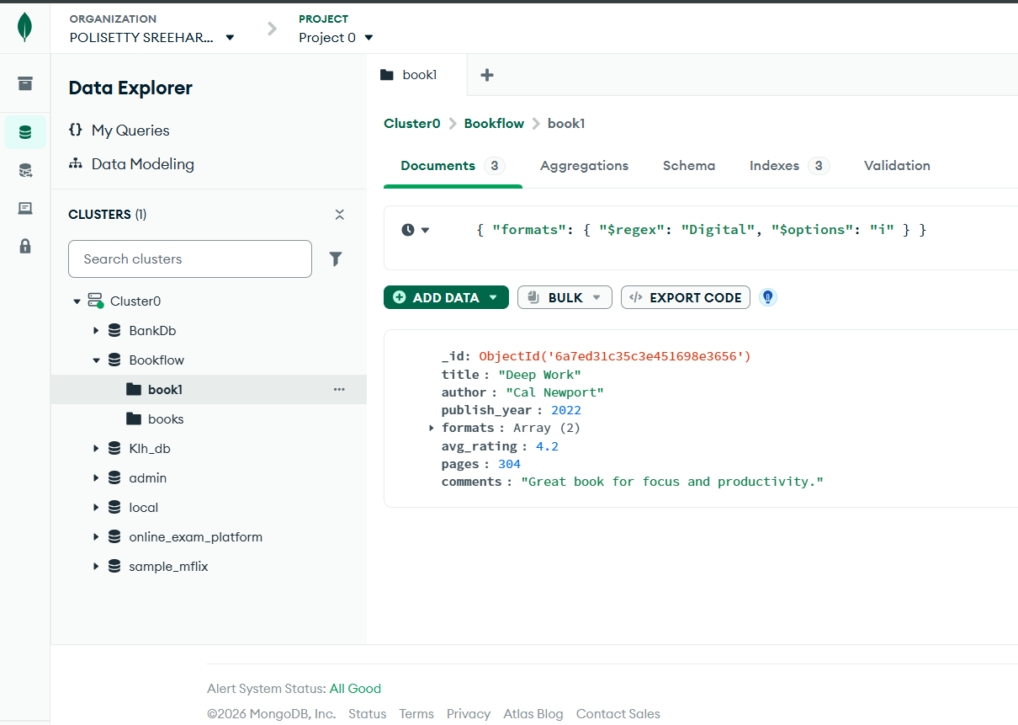

Aggregation Pipeline
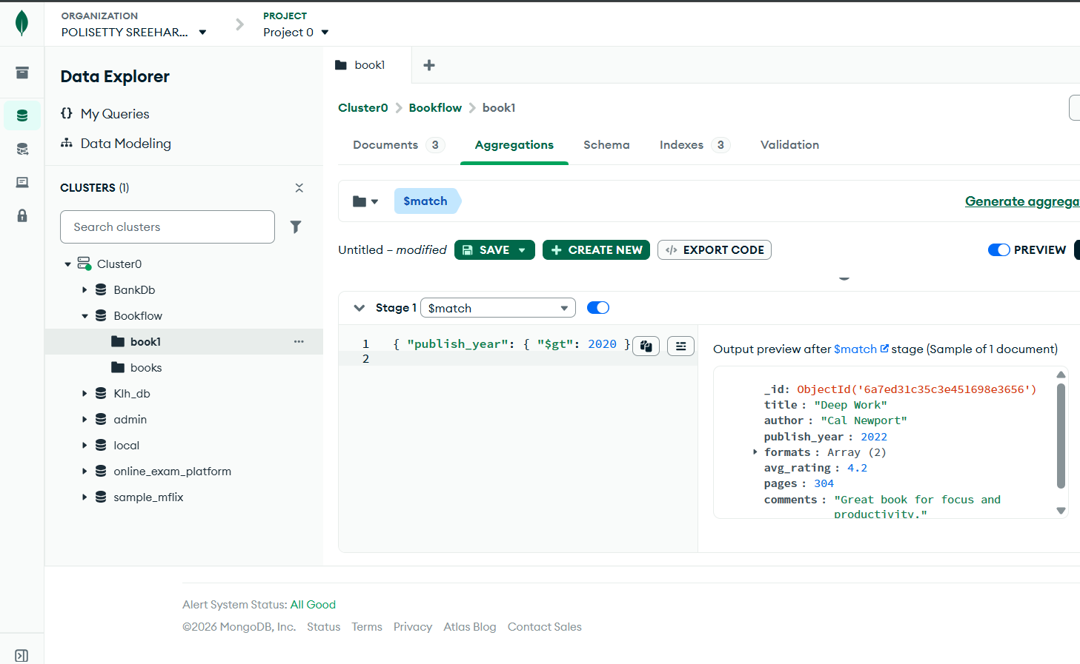
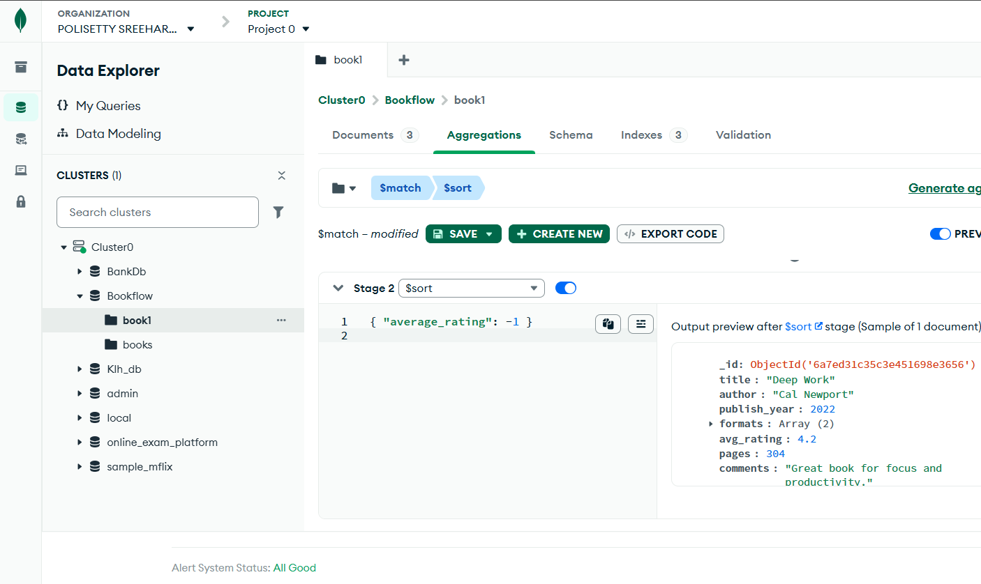
Text Index & Search
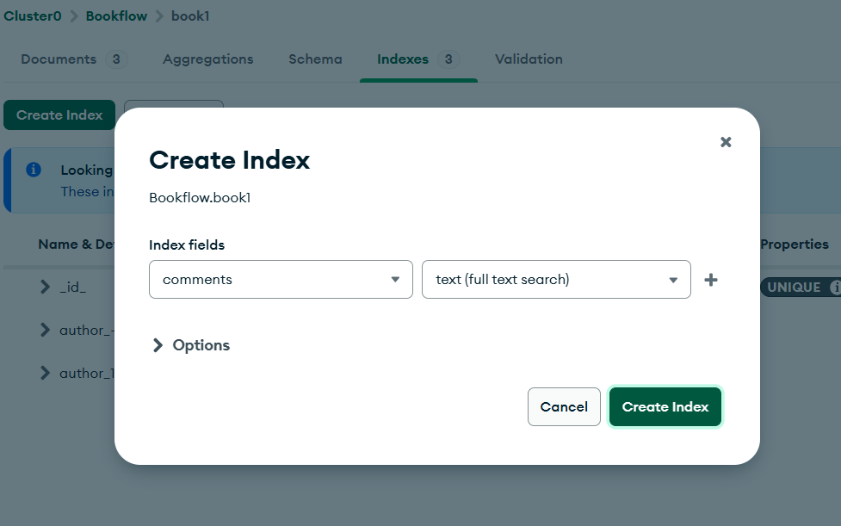
We can search the comments in document tab in the following way by searching for comments.
